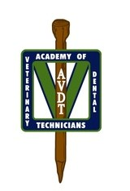

AVDT Mentee Preparation – Quiz 5
Use the diagram below to answer the questions 1-8 regarding anatomy beneath the image.
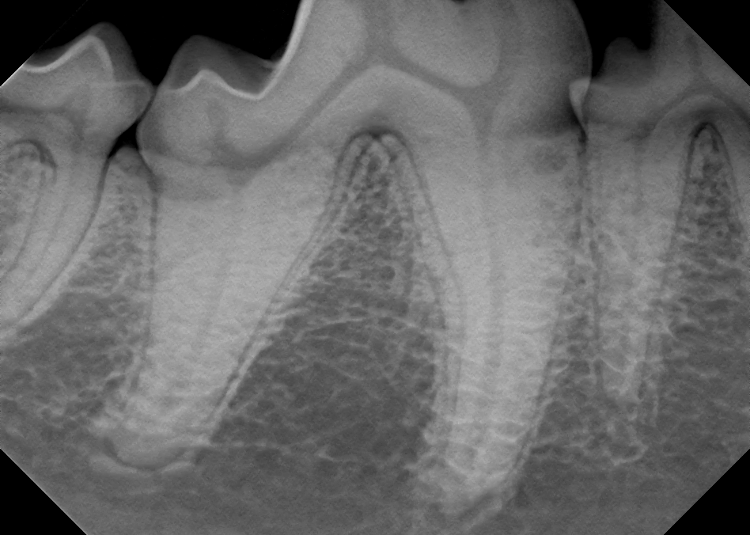

1. The pulp_______ (black arrow)
2. What is the name of the structure? (yellow)
3. The space between roots of same tooth (thin orange)
4. The space between teeth? (green)
5. The space/structure is called _________ (thick purple)
6. The bllack line surrounding teeth? (red)
7. The white line surrounding teeth? (Blue)
8. The term used to desribe this part of the root. (thick orange)
9. What cells are responsible for the production of the following substances?
a. enamel:
b. dentin:
c. cementum:

10. Which of the following substances is the hardest?
a. enamel b. dentin c. cementum

11. What is the difference between tooth resorption types I, II and III as it pertains to treatment options?

12. What is the treatment of choice for tooth resorption types I, II and III?

13. Which of the images below reflect type II tooth resorption? Why? (support your answer)
a. 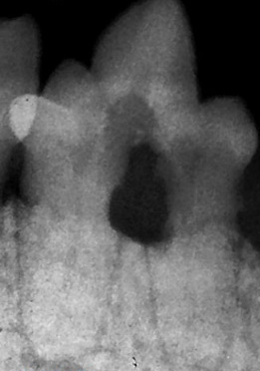 b. 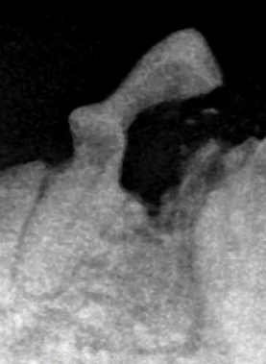 c.

14. Which of the images below reflect type I tooth resorption? Why? (support your answer)
a. b. c.

15. Which of the images below reflect type III tooth resorption? Why? (support your answer)
a. b. c.

