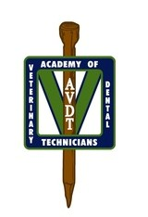

AVDT Mentee Preparation – Quiz 1

- Compare and contrast Hedstrom files and Kerr files using the following criteria:
  - Usage motion
  - Strength
  - Manner of manufacture
  - Direction of cut

- Compare and contrast magnetostrictive (ferrite rod and ferromagnetic stack) and piezoelectric scalers using the following criteria:
  - Portion of the tip that is active (we are looking for a length in mm)
  - The pattern of the tip’s vibration

- List the muscles of mastication and the actions of each.

- How many ways are there to determine if a tooth if vital and explain?

- Use the word pool provided below to describe the dentition of the following species (some species will require the use of multiple terms and some term(s) may not be used at all):

Canine, Feline, Lagomorphs, Caviomorph rodents, Murine rodents, Horse, Shark, Mustelids

Word pool

Brachyodont
Monophyodont
Diphyodont
Polyphyodont
Secodont
Lophodont
Selenodont
Bunodont
Radicular hypsodont
Elodont
Anelodont
Homodont
Heterodont

