AVDT Mentee Preparation – Quiz 3

Name the Structure

- ________________________
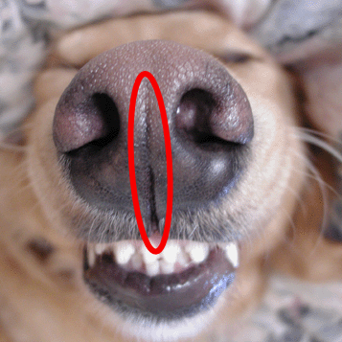

- _________________________
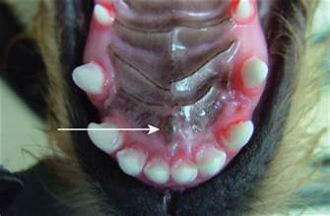

- _________________________ (Name the folds present on the hard palate)
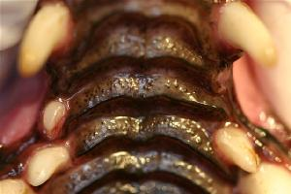

- _________________________ (Name the fold on the lateral aspect of the nose)
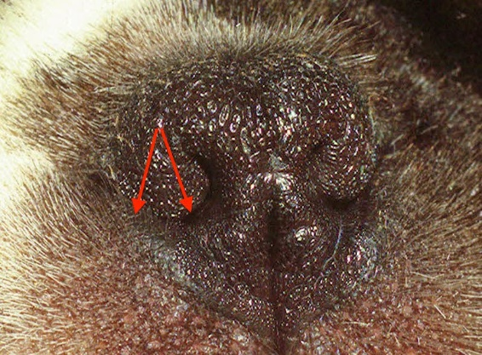

- _________________________
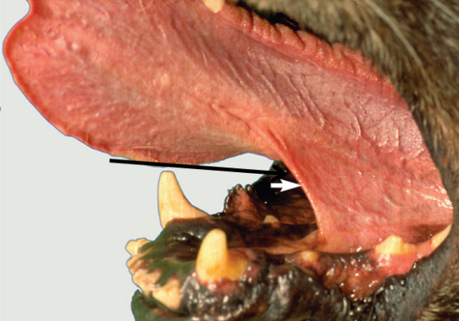

- _________________________ (The name given to the line at the end of the arrow)

- _________________________ (The term given to the “groove” in a feline’s canine tooth)

- _________________________ (Name the structure lingual to the feline mandibular molar)
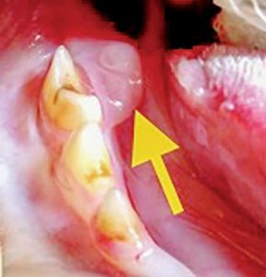

Label the Diagram Below
