AVDT Mentee Preparation – Quiz 5 – Answer Key
Use the diagram below to answer the questions 1-8 regarding anatomy beneath the image.
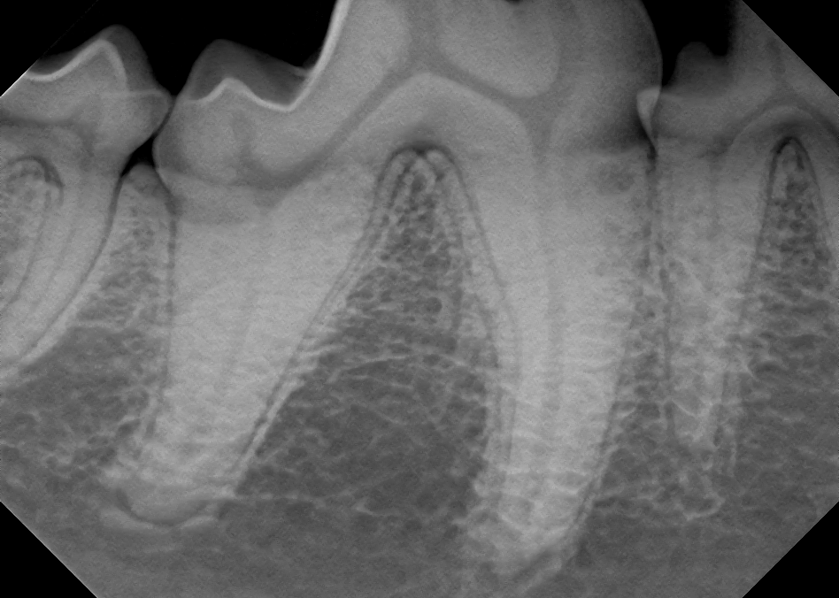

1. The pulp chamber (black arrow)
2. What is the name of the structure? (yellow) root canal
3. The space between roots of same tooth (thin orange) Intraradicular bone
4. The space between teeth? (green) Interdental
5. The space/structure is called furcation or dome of the furcation (thick purple)
6. The bllack line surrounding teeth? (red) periodontal ligament
7. The white line surrounding teeth? (Blue) lamina dura or cibriform plate
8. The term used to desribe this part of the root. (thick orange) Apex
9. What cells are responsible for the production of the following substances?
a. enamel: Ameloblasts
b. dentin: Odontoblasts
c. cementum: Cementoblasts

10. Which of the following substances is the hardest?
a. enamel b. dentin c. cementum

11. What is the difference between tooth resorption types I, II and III as it pertains to treatment options?
Type I: The periodontal ligament or the root canal remains appreciable upon radiographs.
Type II: Ankylosis of the roots such that the periodontal ligament and the root canal are no longer appreciable upon intraoral radiographs.
Type III: A multi-rooted tooth that has at least one root with type I resorption and at least one root with type II resorption
12. What is the treatment of choice for tooth resorption types I, II and III?
Type I: Complete extraction
Type II: Crown amputation
Type III: Complete extraction of intact root (type I) and crownamputation of the root with ankylosis (type II)
13. Which of the images below reflect type II tooth resorption? Why? (support your answer)
a. 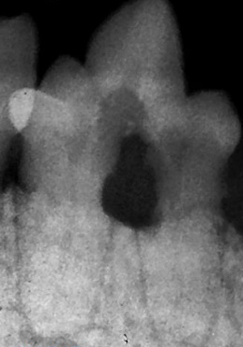 b. 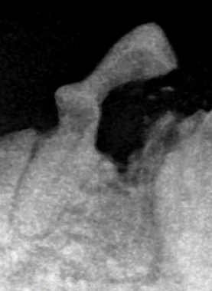 c.
c. Both roots are experience ankylosis; (cannot visualize the periodontal ligament or the root canal)

14. Which of the images below reflect type I tooth resorption? Why? (support your answer)
a. b. c.
a. Both roots are intact

15. Which of the images below reflect type III tooth resorption? Why? (support your answer)
a. b. c.
b. Has one intact root and one with ankylosis.

