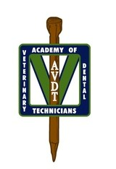

AVDT Mentee Preparation – Quiz 4

- What exotic species has a second row of maxillary incisors known as peg teeth? What is the term used to describe this phenomenon?

- Which exotic species is prone to scurvy?

- List three common murine rodents.

- List three common caviomorph rodents.

- What is the difference between murine and caviomorph rodents in regards to dentition? (Specifically, the differences in formula and description of the teeth)

- What is the dental formula for the following common exotic species?
  - Rabbits
  - Murine rodents
  - Caviomorph rodents
  - Ferrets

- Rabbits are an exotic species that presents with two types of malocclusion, which are atraumatic and traumatic. Compare the two types of malocclusions in regards to the common cause, treatment options, and prognosis.

- Discuss cheek pouch eversion and cheek pouch impaction. Include the exotic species that are often affected, describe the condition and treatment options for both.

- Why do the incisors of rodents have a yellow to orange color?

- What term describes the large gap between the incisors and cheek teeth in rabbits?

- What two terms can describe the continuously growing teeth of rabbits?

